Supplementary Material

Overview
We conducted the literature search, screening, and coding for the replication benchmark in accordance with the Preferred Reporting Items for Systematic Reviews and Meta-Analyses (PRISMA) 2020 statement (Page et al., 2021). We adapted the statement to a benchmark whose unit of analysis is the formally stated hypothesis rather than the effect size. Figure 1 illustrates the selection process from database records to the final set of hypotheses.We searched a predefined set of journals (the UTD 24 and FT50 lists plus Personnel Psychology, The Leadership Quarterly, and Journal of Organizational Behavior) for empirical research on abusive supervision published from 2000 onward and retrieved 353 records. Screening yielded 110 primary empirical articles in which abusive supervision is studied as a predictor of outcomes. Together with 12 meta-analyses and 4 articles on closely related constructs kept for reference, 126 full texts (317 studies, 1,528 formally stated hypotheses) were coded. The replication benchmark is restricted to hypotheses in which abusive supervision itself is the independent variable and no moderator is involved (direct and mediated effects): 284 hypotheses from 60 articles. After removing hypotheses that cannot be implemented in a single-team office simulation, such as those requiring family-member raters, customers, higher-level managers, or non-office outcomes, the benchmark comprises 225 hypotheses from 82 studies in 52 articles (the 82 studies comprise 59 surveys, of which 39 are multiwave and 20 cross-sectional, 7 experience-sampling or diary studies, and 16 experiments, of which 7 are vignette, 5 recall, 3 laboratory, and 1 field experiment). The hypotheses are measured with 286 respondent-rated variables drawing on 103 distinct scales.
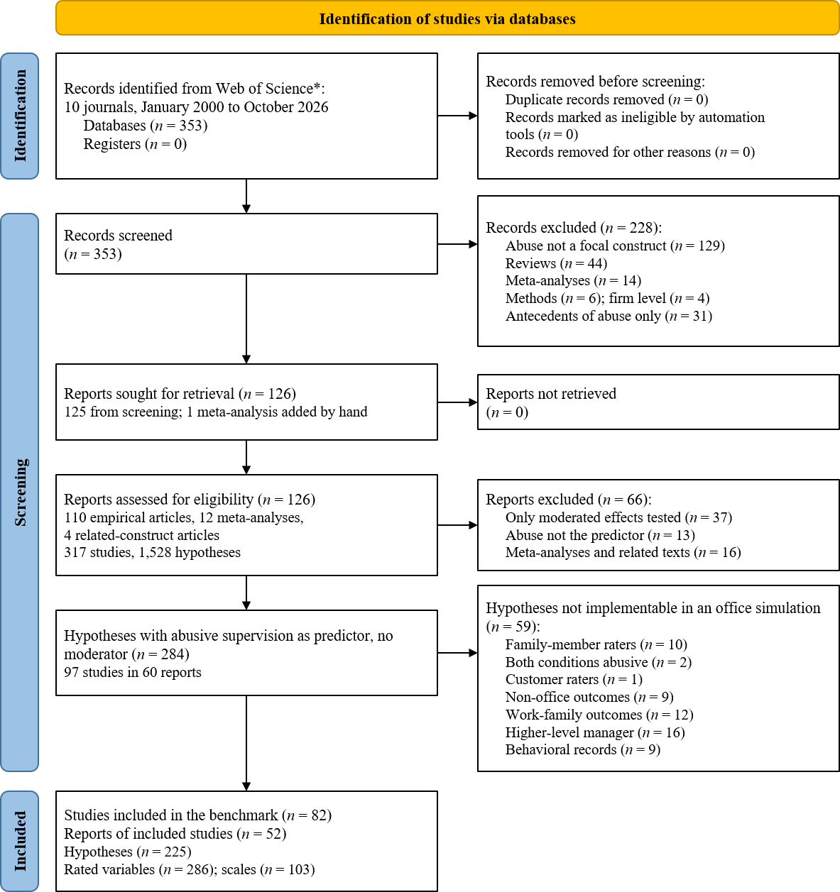
Figure 1. PRISMA flow diagram of the article selection and hypothesis selection process.

Construction of the Replication Benchmark

Literature Search
We defined the journal set by an explicit rule before searching. From the University of Texas at Dallas (UTD) list of 24 leading business journals and the Financial Times research list of 50 journals (FT50), we took the seven journals that publish research on organizational behavior and management: Academy of Management Journal, Administrative Science Quarterly, Organization Science, Journal of Applied Psychology, Organizational Behavior and Human Decision Processes, Journal of Management, and Journal of Management Studies. We added three journals that neither list includes but that publish much of the research on leadership and organizational behavior: Personnel Psychology, The Leadership Quarterly, and Journal of Organizational Behavior. All seven journals appear on the FT50 list both before and after its April 2026 revision, which removed Human Relations, Journal of Business Ethics, and Organization Studies. The search returned records from nine of the ten journals. Administrative Science Quarterly returned none.
We searched the Web of Science Core Collection on October 2, 2026 (U.S. Eastern Time) for articles published in the ten journals from January 2000, the year in which Tepper (2000) introduced the construct, through the search date. The search string targeted the construct name in titles, abstracts, and keywords and identified the journals by their ISSNs rather than their titles, so that journals with similar titles were not picked up: TS=(“abusive supervision” OR “abusive supervisor*” OR “supervisor* abuse” OR “abusive leader*” OR “supervisory abuse” OR “abusive manager*”) AND IS=(0001-4273 OR 0001-8392 OR 1047-7039 OR 0021-9010 OR 0149-2063 OR 0749-5978 OR 0022-2380 OR 0031-5826 OR 1048-9843 OR 0894-3796) AND PY=(2000-2026) AND DT=(Article OR Review). We included the document type Review so that meta-analyses indexed as reviews would not be missed. We applied no language filter, because all ten journals publish in English. The search returned 353 records, each with a unique Web of Science identifier and DOI, so no duplicate records had to be removed before screening.
We restricted the search to these journals for two reasons. First, a simulation should be calibrated against the findings that the field treats as established, and these journals publish most of the studies that define those findings. Second, articles in these journals report their hypotheses, measures, and estimates in enough detail to be coded at the hypothesis level. This restriction trades coverage for comparability. To represent findings published elsewhere, we retained 12 meta-analyses as reference material (see Screening Process). We added one of these meta-analyses, Zhang and Liao (2015) in Asia Pacific Journal of Management, by hand because it is a standard reference synthesis of the outcomes of abusive supervision. We did not conduct a backward search of reference lists, because studies published outside the journal set fall outside the intended scope of the benchmark.

Inclusion and Exclusion Criteria
We included an article in the coded corpus if it met four criteria: (a) the article reported original quantitative empirical research, (b) the article treated abusive supervision as a focal construct, whether measured or manipulated, where abusive supervision refers to subordinates’ perceptions of the extent to which supervisors engage in the sustained display of hostile verbal and nonverbal behaviors, excluding physical contact (Tepper, 2000), (c) the article stated at least one formal hypothesis involving abusive supervision, and (d) the article was published in English in one of the journals of the set within the search window.
We excluded conceptual articles, narrative reviews, qualitative studies, methodological articles without substantive hypotheses, and studies at the firm or chief executive level. We set aside articles that examined abusive supervision only as an outcome, because the benchmark concerns the consequences of abusive supervision. These antecedent articles remain coded and available for future work. We retained meta-analyses and articles on closely related constructs (supervisor aggression, leader toxicity, leader mistreatment, and supervisory mistreatment) as reference material, but we did not include their hypotheses in the replication benchmark.

Screening Process
Claude (in Opus 5.5 mode), a large language model, screened the titles, keywords, and abstracts of all 353 records against the criteria above. The screening ran in four parallel batches under one written codebook, and each record was judged by reading it rather than by keyword matching. The first pass included 140 records, excluded 206, and left 7 undecided. Claude then adjudicated the 7 undecided records from their abstracts. It included one article on downward hostility, which matches Tepper’s (2000) definition, set aside four articles on closely related constructs to be judged on their full texts, and excluded two, one on tyrannical leadership and one in which abusive supervision was one component of a latent leadership profile. Finally, the first author reviewed all of the screening decisions.
The screening excluded 197 records. Of these, 129 did not treat abusive supervision as a focal construct, most of them because they examined related but distinct constructs such as incivility, social undermining, ostracism, or authoritarian leadership. Another 44 were conceptual or review articles, 14 were meta-analyses with little bearing on abusive supervision, 6 were methodological or measurement articles, and 4 were studies at the firm or chief executive level. No record was excluded as a purely qualitative study. The screening retained 141 empirical articles on abusive supervision, 11 meta-analyses (2 devoted to abusive supervision and 9 that include abusive or destructive leadership), and 4 articles on closely related constructs.
Among the 141 empirical articles, 31 examined abusive supervision only as an outcome, and we set them aside. The remaining 110 primary empirical articles, the 12 meta-analyses (11 from the search and 1 added by hand), and the 4 related-construct articles formed the coded corpus of 126 full texts.

Coding Procedure
Coding proceeded in three steps, with the research team setting the rules and checking the output at each step. First, we developed the coding workbook and the codebook, which define the fields at each level and the rules for coding each field. Second, Codex (in GPT-6.1 Sol mode, reasoning effort set to high) coded six pilot articles chosen to span the main designs in the corpus: multiwave surveys, cross-lagged panels, a diary study, experiments, third-party reactions, and multistudy articles. We checked the coded hypotheses against the articles over two rounds, corrected the errors, and revised the codebook and the workbook template wherever an error revealed an unclear rule. Third, GPT-6.1 Sol (reasoning effort set to high, accessed through the OpenRouter API) coded the remaining 120 articles from their full-text PDFs according to the revised codebook and workbook template, one article per request. The codebook required the model to record the page number of every entry and to flag for human review, rather than guess, anything the article did not report clearly. The coding script checked each output against the codebook’s schema and self-checks (for example, that every variable named in a hypothesis exists and that every supported hypothesis carries an estimate) and resubmitted failed outputs once with the error messages.

Selection of Hypotheses for Replication
We selected the hypotheses for the benchmark in two steps. In the first step, we retained a hypothesis if abusive supervision itself served as the independent variable and the hypothesis involved no moderator. This criterion keeps direct effects and mediated effects, and it sets aside moderated and moderated-mediation hypotheses, which remain coded and available for future work. The first step retained 284 hypotheses from 97 studies in 60 articles. Of the other 50 primary empirical articles, 37 tested abusive supervision only in moderated hypotheses, and 13 did not treat abusive supervision as an independent variable in any hypothesis.
In the second step, we excluded hypotheses that a single-team office simulation cannot implement. The base simulation contains one team leader and several employees who work together in an office, so we excluded hypotheses whose outcome or rater lies outside that setting. Table 1 lists the exclusion reasons in the order in which we applied them. The second step removed 59 hypotheses and left 225 hypotheses from 82 studies in 52 articles. Eight articles and 15 studies lost all of their eligible hypotheses in this step.
Table 1. Hypotheses excluded because the office simulation cannot implement them
Exclusion reason | Rationale | Hypotheses removed | Hypotheses remaining
Starting set | Abusive supervision as the independent variable, no moderator | — | 284
Family-member raters | A spouse or another family member rates the outcome, and the simulation contains no family members. | 10 | 274
Both conditions abusive | One article compares two abusive conditions that differ only in the attributed motive, whereas the simulation contrasts abusive with non-abusive leadership. | 2 | 272
Customer raters | A customer rates the outcome, and the simulation contains no customers. | 1 | 271
Non-office outcomes | The outcome exists only outside an office, such as food waste in a restaurant kitchen or safety performance of pilots. | 9 | 262
Work–family outcomes | The outcome concerns the interface between work and family, and the simulation contains no home domain. | 12 | 250
Higher-level manager | The hypothesis requires a manager above the team leader as a rater or an actor, and the base simulation has only one leader. | 16 | 234
Behavioral records | The outcome is recorded behavior rather than a questionnaire response, and the operational definitions and coders for these outcomes are deferred. | 9 | 225
We retained hypotheses regardless of whether the original authors reported them as supported. Of the 225 hypotheses, the original articles reported 174 as supported, 2 as partially supported, and 25 as not supported, and 24 hypotheses did not receive an explicit verdict in the original articles.

Characteristics of the Final Benchmark
The 52 articles appeared in Journal of Applied Psychology (16), Journal of Organizational Behavior (10), Academy of Management Journal (9), The Leadership Quarterly (7), Journal of Management (4), Organizational Behavior and Human Decision Processes (2), Personnel Psychology (2), Organization Science (1), and Journal of Management Studies (1). No article from Administrative Science Quarterly entered the final benchmark. The articles were published between 2000 and 2026.
The 82 studies fall into three non-overlapping groups by primary design: 59 surveys (39 multiwave and 20 cross-sectional, with 1 study in each group also using archival data), 7 experience-sampling or diary studies (1 of which also included a multiwave survey), and 16 experiments. The 16 experiments comprise 7 vignette experiments (2 of which also used a recall manipulation), 5 recall experiments (1 of which was combined with a multiwave survey), 3 laboratory experiments, and 1 field experiment (which also used a recall manipulation and a diary design). In 49 studies, the targeted subordinates reported abusive supervision. The researchers manipulated it in 15 studies, supervisors reported their own abusive behavior in 10, the researchers aggregated it to the team level in 4, observers reported it in 3, and 1 study used another approach.
The studies drew their samples from the United States (23 studies, plus 1 study that sampled the United States and Canada), China (20), the Philippines (7), Canada (3), Ghana (3), South Korea (2), and Brazil, Italy, the Netherlands, Taiwan, and the United Kingdom (1 each). The coding did not record a country for 18 studies. Across the 71 studies that reported mean age and the 71 that reported the share of women, participants had a mean age of 34.4 years, and women made up 48.6% of participants on average (unweighted means of the study-level values). The studies’ level-1 samples total approximately 25,400 participants when samples reported twice are counted once: Tepper et al. (2007) reanalyze the sample of Tepper (2000), and Study 3 of McAllister et al. (2018) and Study 1 of Mackey et al. (2018) appear to use the same panel sample. Summing all 82 studies gives 25,829.
The 225 hypotheses comprise 77 direct effects (including 2 crossover effects), 80 simple mediation effects, 41 parallel mediation effects, 9 serial mediation effects, 17 reciprocal cross-lagged effects, and 1 curvilinear effect.

Measurement Materials
The 225 hypotheses involve two kinds of variables: 286 variables measured by questionnaire, drawn from 103 distinct scales, and 20 variables that the original studies manipulated experimentally.
Manipulated variables are reproduced through the leader’s condition. The high-abuse condition corresponds to the original abuse condition and the low-abuse condition to its control condition. In the original experiments, control conditions involved non-abusive leader behavior, described as neutral, respectful, or professional, and recall designs asked participants to recall a non-abusive or positive experience. Only Study 3 of Taylor et al. (2019) did not report its control condition separately. The low-abuse condition therefore represents ordinary leadership without abuse rather than deliberately positive leadership.
For each questionnaire variable, we prepared a questionnaire that matches the original study in three respects: the rater (whether the employee, the leader, or a coworker answers), the referent (whom the items describe, such as “my supervisor” in employee reports or “this subordinate” in leader self-reports), and the number of items (a short form in the original is reproduced as the same short form).
We chose each questionnaire in the following order of priority. First, we used the items printed in the target article whenever the article printed them (39 variables). Second, when the article adapted a scale without printing the adapted items, we wrote a restored version that applies the adaptation the article describes, such as a changed referent, timeframe, or rater, to the parent scale (91 variables). We labelled each restored item by its basis: wording taken from the target article, an adapted item of the parent scale, or an item written to complete the restoration. Third, we used a version that another article in the corpus printed for the same rater (89 variables). Fourth, we used the original source scale (67 variables). When the chosen version had more items than the target study used, we kept the items printed in the target article first and then selected the remaining items evenly across the scale (43 variables). One variable has fewer items than the original: organizational citizenship behavior directed at the organization in Study 1 of Priesemuth and Bigelow (2020), whose questionnaire lacks one of the seven items of Williams and Anderson’s (1991) scale (“Conserves and protects organizational property”). We will restore the item before the main runs. The remaining 242 variables use their questionnaires without trimming. For two constructs whose original items are not publicly available, we substituted public instruments that measure the same construct. Anxiety in Tepper (2000), measured there with an unpublished scale (Robins, 1986), is measured with a six-item version adapted from the GAD-7 (Spitzer et al., 2006), and anger in Ferris et al. (2016), measured there with a proprietary scale by Spielberger, is measured with 14 emotion adjectives. Both substitutions remain within the final 225 hypotheses.
Employees rate themselves on 132 of the 286 variables, employees rate their leader on 68, leaders rate themselves on 32, and leaders rate employees on 28. Other raters, such as team members, coworkers, and scenario participants, answer the remaining 26 variables. The agents answer the items in their original English wording. In the Chinese-language version of the simulation, which all runs so far have used, the instructions and context around the items are in Chinese while the items remain in English. In the English-language version, all text is in English.

Simulation Setup
This section summarizes how the pilot data were generated. The reproduction package contains the platform code, the world templates, personas, and prompt templates used in the runs, and a questionnaire administration schedule that lists, for each questionnaire, its raters, times, recall window, scale, and the article variables it serves.

Platform and Model
We ran the simulation on Workplace Simulation Lab, a layered simulation platform we built on the generative agents of Park et al. (2023). Each agent perceives its surroundings, stores its experiences in a memory stream, retrieves and reflects on memories, plans its day, moves through the office, and talks with other agents. The platform has eight layers that form three systems. The agent system defines who each agent is, through a memory, reflection, and planning core, a personality layer, and a fixed role and background that reflection cannot rewrite. The world system defines what happens between agents, through shared world rules, perception and action in a tiled office, and social interaction in which each agent’s actions enter the perception and memory of the others, so that bystanders witness events without any additional injection. The researcher interface lets a manipulation be written into a persona or the world rules or injected as an event, and it administers questionnaires with passive measurement that leaves no trace in the agents’ memories and records every conversation, reflection, and questionnaire context as structured logs.
All agents ran on one base model, DeepSeek-V4.1-Flash (version 1017, named deepseek-flash in the platform), accessed through the official DeepSeek API with its thinking mode turned off. The same model generated every schedule, action, conversation, reflection, importance rating, and questionnaire answer. Memories were embedded with bge-m3, served locally. No researcher intervened during any run, and no scripted event was scheduled.

Team, World, and Personality
Each world is a four-person team in the marketing operations department of a medium-sized company. Klaus (age 45) is the team lead, and Ayesha, Maria, and Wolfgang (each age 28) are marketing operations specialists. Klaus assigns tasks and evaluates the team members’ performance, and his evaluations affect their bonuses and promotions. One leader and three employees provide every rater that the 225 hypotheses require, including two coworkers for each employee who can serve as observers and peer raters, and a supervisor who directly manages several subordinates is the most common sampling unit in the original studies. Each world simulates five workdays. Shared world rules give the behaviors that the scales measure, such as helping, taking leave, raising concerns, and outside job opportunities, a channel that exists in the world, and both conditions use the same rules.
Each agent’s personality comes from a real respondent. This ensures that every agent carries a combination of traits that actually occurs in people, with the covariation among the five domains found in real data, and that personalities across agents vary as they do in a real population rather than being set by the researchers. The pool contains 9,830 complete answers to the 50-item IPIP Big Five questionnaire from respondents aged 22 to 55, taken from the public Big Five dataset of Open Psychometrics (Goldberg et al., 2006; Open-Source Psychometrics Project, n.d.). Each domain is written into the persona as a short phrase, with no numbers. Worlds with the same personality set have the same four personalities whatever their condition, and the high- and low-abuse conditions are not matched one to one, which the sensitivity analyses address.

Leadership Manipulation
The two conditions differ in one paragraph only, the leadership style in Klaus’s fixed layer. A field-by-field comparison of the two world templates found no other difference. Only Klaus reads this paragraph. The employees experience his leadership only through their interactions with him and through what they see and hear.
Both paragraphs follow Tepper’s (2000) definition of abusive supervision as sustained hostile verbal and nonverbal behavior, excluding physical contact. Both are written as fixed habits that Klaus has formed over years of leading the team. They describe only behavior that others can see and contain no evaluative words, no motives, and no fluctuation, which would turn the manipulation into one of variability. The nine practices correspond one to one. The low-abuse leader holds the same high standards but criticizes the work rather than the person.
The leadership style, like the rest of each persona, is written in the third person (“Klaus has led the team for many years …”). This follows the generative agents architecture on which the platform is built, in which each agent’s identity, memories, and plans are stored as third-person statements about the agent, and each prompt asks the model what that person would do or say (Park et al., 2023). Both conditions use the same framing, so the grammatical person is held constant and cannot produce a difference between them. The manipulation checks also show that the leader took the described habits as his own conduct, because his self-reported abuse separated the two conditions completely (Table 3).
The prompt in the high-abuse condition was:
Klaus has led the team for many years and has developed a fixed set of habits in how he talks and works. He has always been this way with the team members, not only when they make mistakes. When he talks, he often uses rhetorical questions and sarcasm; his words have a sting and leave people with no way to save face on the spot. Specifically, he is in the habit of:
1. laughing at team members’ work in front of other coworkers, saying their ideas and feelings are stupid and that they are not capable, for example “What’s going on in that head of yours?”, “Even an intern could do this better than you.”, “You have the nerve to hand in work at this level?”;
2. bringing up team members’ past mistakes and failures, for example “Still haven’t learned from last time?”;
3. picking apart every part of what they hand in, making them redo it again and again without saying clearly what to change, changing requirements at the last minute and shortening deadlines, and then pointing out that they did not finish;
4. when reporting to the manager, presenting the results the team members produced as his own, and saying that problems are the team members’ fault;
5. speaking to team members in a sharp tone, interrupting them, sighing, rolling his eyes and sneering, and snapping at team members even when nothing in particular has happened;
6. sometimes not answering team members’ messages, ignoring them, acting as if they were not there;
7. talking about team members’ faults in front of other coworkers and the manager, in a dismissive tone;
8. not keeping the promises he makes to team members, and sometimes telling them things that do not match the facts;
9. asking about and talking about team members’ private lives, and telling them to spend less time with other coworkers.
He never gets physical and has no physical contact of any kind.
The prompt in the low-abuse condition was:
Klaus has led the team for many years and has developed a fixed set of habits in how he talks and works. He has always been this way with the team members. He sets high standards for the work and never lets up on progress or quality, but his criticism is aimed at the work, not at the person. When he talks, he is direct and calm, uses polite words, and does not use rhetorical questions or sarcasm. Specifically, he is in the habit of:
1. when team members make mistakes, pointing out in private what the problem is and why, and setting concrete requirements for improvement, without laughing at anyone or judging their ability or character;
2. dealing with each matter on its own terms, without bringing up team members’ past mistakes;
3. making requirements clear in advance, saying exactly what to change when something needs to be redone, and explaining why when he changes requirements or adjusts deadlines, while allowing reasonable time;
4. when reporting to the manager, stating truthfully who produced the results, and taking his own share of responsibility as team lead first when problems arise;
5. speaking politely to team members, hearing out their ideas, explaining his reasons even when he disagrees, and not snapping at them;
6. responding promptly when team members come to him;
7. not talking about team members’ faults in front of other coworkers or the manager;
8. keeping the promises he makes to team members and telling them the truth;
9. not asking about or discussing team members’ private lives, and not interfering with their contact with other coworkers.
All pilot runs used the Chinese-language version of the platform, and the Chinese text above is the text the leader agent read. The English text is the version used in the English-language platform.

Questionnaire Administration
Each world administers 270 questionnaires: the 259 replication questionnaires described in Measurement Materials and 11 questionnaires that the platform adds, namely ten daily measures, including two manipulation checks, and an IPIP-50 personality check on the first morning. Each questionnaire is answered by the rater of the original study, in a self-report or in a dyadic rating for each person rated. Agents see neutral titles that reveal nothing about the research question, and items are shuffled on each occasion. Each answer comes from a separate model call whose context combines the agent’s experiences of the day, earlier memories, and its impressions of colleagues. Table 2 shows how the measurement times of the original studies are compressed into five workdays. A world yields 1,051 questionnaire answers, and the 70 worlds yielded 70,584.
Table 2. Measurement times in the simulation
Measurement in the original study | Time in the simulation
Single survey, measurement after an experimental manipulation, or no stated time | Day 5 (the last workday), 21:00
Two waves | Days 3 and 5, 21:00
Three waves | Days 3, 4, and 5, 21:00
Four waves | Days 2 to 5, 21:00
Five waves | Days 1 to 5, 21:00
Six waves | Days 1 to 5 at 21:00, plus day 1 at 08:00
Baseline (T0) | Day 1, 08:00
Diary study | Every day, at the time of day of the original study (12:00, 17:00, 21:00, or 08:00 for morning reports)
Daily measures added by the platform | Every day: morning recovery at 08:00, all others at 21:00
The 70 analyzed worlds, 35 in each condition, ran in four batches with identical templates and questionnaires. Ten worlds that a rerun completed on a different base model were excluded.

Analysis

Scoring and Hypothesis Tests
Each item answer is rescaled to the range 0 to 1, reverse-keyed items are reversed, and a variable is the mean of its items. Each wave of a multiwave design is a separate variable at its own time point. Measures that the original studies administered daily, in diary and experience-sampling designs and in one field experiment, are administered on each simulated day, and the main analysis averages them over the week. This departs from the original designs, which analyzed these measures day by day, so in the main analysis the diary hypotheses are tested as relations between persons. The within-person tests and the multilevel models described below test them day by day, and the Results report both.
Each hypothesis keeps the structure of the original test: its independent variable, mediators, and outcome, their raters, and the order in which they were measured. The independent variable is the abusive supervision score measured in the simulation, rated by the same rater as in the original study. A hypothesis is analyzed across agents when all of its variables can be matched on the same agents, which applies to 167 of the 179 testable hypotheses, and otherwise across the 70 worlds. Direct effects are regression slopes, and indirect effects are products of the path coefficients, each path controlling for the independent variable and earlier mediators.
The core of the simulation is to replicate the theoretical hypotheses of the original studies, not to reproduce their research designs in full. The simulation therefore does not rebuild the experimental procedures of the original experiments, such as reading a scenario, a recall task, or a laboratory task. All studies share one structure, a between-world experiment in which the leader’s persona is assigned to the high- or low-abuse condition. Employees do not imagine being abused after reading a description. They experience the leader’s conduct over five workdays, so the structure is closer to a field experiment. Where the original study manipulated abuse, the world’s condition (high abuse = 1, low abuse = 0) takes the place of the manipulated variable. Experiments that rely on recalling past experience or that involve a second leader cannot be realized in a world with one leader and no prior history, so we coded them as design mismatches. Of the 37 hypotheses from experiments, 14 are testable.
Agents in the same world are interdependent, so inference uses a cluster bootstrap that resamples whole worlds (2,000 draws). A hypothesis is replicated when its effect has the predicted direction and its 95% confidence interval excludes zero, and a predicted null is replicated when the interval includes zero. Every testable hypothesis falls into one of five outcomes: replicated, predicted direction but not significant, opposite direction and not significant, opposite direction and significant, and significant although the original study predicted no effect.

Robustness Analyses
Five analyses check the main result. Three concern inference and sampling: mediation judged by the joint significance test, an analysis restricted to the personality sets that appear in both conditions, and a bootstrap clustered by personality set instead of by world. The fourth tests the diary hypotheses within persons, day by day, with each variable centered on the person’s own mean.
The fifth, a model-faithful re-estimation, re-estimates the 81 testable hypotheses whose original model differs in structure from the uniform estimator of the main analysis, with models closer to the original ones. The mediators of a parallel model are estimated jointly. Cross-lagged effects control for the earlier wave of the outcome. Diary hypotheses are estimated with multilevel models that separate within- and between-person variation, with 1-1-1 mediation and Monte Carlo intervals. Team-level hypotheses are estimated on world means, and the one hypothesis with a team-level predictor and individual-level mediator and outcome as a 2-1-1 mediation. Control variables, latent decomposition of variance, and random slopes are not reproduced.

Predictors of Replication and Boundaries of the Method
This analysis maps the boundaries of the method. A replication rate alone does not tell a researcher whether the simulation can be trusted to test a new hypothesis, so we asked which kinds of hypotheses replicate and which do not, using only features that are known before any simulation is run. To this end, we coded each of the 179 testable hypotheses for features fixed in advance and independent of the simulation results, among them the perspective, the prediction structure (harm, benefit or adaptive response, or no effect), the time window, and the outcome’s type, valence, target, and hostility. Two independent instances of Claude Opus 5.5 coded these features from a written codebook, the second in a separate session without access to any simulation result. Agreement was high (Cohen’s κ of 0.90 to 1.00 on all dimensions but outcome target, 0.69), disagreements were resolved one by one against the codebook definitions with the reason for each recorded, and a human coder will recode the hypotheses for the main study. Replication is the dependent variable of a Firth-penalized logistic regression with a bootstrap over original articles, and an ordinal regression and the within-person results serve as robustness checks. Features that predict failure mark the boundaries of the method, which the Results report as Boundaries 1 to 4.

Cost Estimate
We compared the cost of the simulation with a lower-bound estimate of the human data collection that the same studies required, following the method of AITurk (Qin et al., 2024): participants and questionnaires are counted from the final samples of the 73 studies with sample information and priced at crowdsourcing rates.

Results

Manipulation Checks
On all five indicators of abusive supervision, every one of the 35 high-abuse worlds scored above every one of the 35 low-abuse worlds (Table 3 and Figure 2a). The conditions separated completely whether abuse was reported by the targeted employees, by coworkers who observed it, or by the leader himself, on the daily scales and on the scales used in the original studies (Cohen’s d = 2.3 to 5.3, Mann–Whitney p < 10⁻¹²). The leader’s persona only describes his habits of conduct and asks no one to report abuse, so all three ratings come from behavior that the agents experienced or enacted during their interactions.
Table 3. Manipulation checks (world-level means rescaled to 0–1)
Indicator | Rater | High abuse M (SD) | Low abuse M (SD) | d
Daily abusive supervision (Mitchell & Ambrose, 2007, five items) | Employees rate the leader | 0.25 (0.12) | 0.00 (0.00) | 2.9
Daily observed abuse of coworkers (Xu et al., 2020) | Coworkers as bystanders | 0.11 (0.07) | 0.00 (0.00) | 2.3
Daily self-reported abusive behavior (Liao et al., 2018) | Leader self-report | 0.12 (0.06) | 0.00 (0.00) | 2.8
Abusive supervision scales of the replication questionnaires | Employees rate the leader | 0.30 (0.08) | 0.01 (0.01) | 5.1
Abusive supervision scales of the replication questionnaires | Leader self-report | 0.42 (0.11) | 0.00 (0.00) | 5.3
In the high-abuse condition, employees reported some abuse on 65% of employee-days, against none in the low-abuse condition. The manipulation was stable across batches (Mann–Whitney p = .19 to .56) and carried through to downstream outcomes. In the high- against the low-abuse condition, employees’ emotional exhaustion averaged 0.72 against 0.22 and turnover intention 0.39 against 0.08, the leader’s perceived loss of moral credits averaged 0.25 against 0.00, and employees’ mood fell by 1.0 point over the week in the high-abuse condition and rose by 2.4 points in the low-abuse condition (on a scale from 1 to 10).

Replication Rate
Of the 225 hypotheses, 179 were testable in the current setting. Of these, 146 (81.6%) replicated, and 161 (89.9%) showed the predicted direction (Table 4 and Figure 2b). Nine hypotheses (5.0%) were significantly reversed. Among the 134 testable hypotheses that the original studies supported, 105 (78.4%) replicated and 117 (87.3%) showed the predicted direction.
Table 4. Replication outcomes of the 179 testable hypotheses
Outcome | Hypotheses | Share
Replicated (predicted direction, significant) | 146 | 81.6%
Predicted direction, not significant | 15 | 8.4%
Opposite direction, not significant | 6 | 3.4%
Opposite direction, significant | 9 | 5.0%
Significant, although the original study predicted no effect | 3 | 1.7%
Predicted direction in total | 161 | 89.9%
The result held in all three robustness analyses of inference and sampling. With mediation judged by the joint significance test, 145 hypotheses (81.0%) replicated. Keeping only the personality sets shared by both conditions, 144 (80.4%) replicated and 159 (88.8%) showed the predicted direction. With the bootstrap clustered by personality set, the result was identical to the main analysis (146 replicated). Under the model-faithful re-estimation, 128 of the 179 hypotheses replicated (71.5%) and 159 showed the predicted direction, and 97 of the 134 originally supported hypotheses replicated (72.4%). The reasons for this decline are discussed below.
The 46 untestable hypotheses fall into three groups. Twenty-four require designs that a world with one leader and one team cannot implement: abuse by a former leader (12), comparisons between two leaders (9), and abuse differentiation or justice climate strength, which require several units (3). Seven involve a variable with no variance in the simulation. Thirteen involve variables of some experimental studies that were not administered in this round of simulation, and 2 predict a nonlinear form.
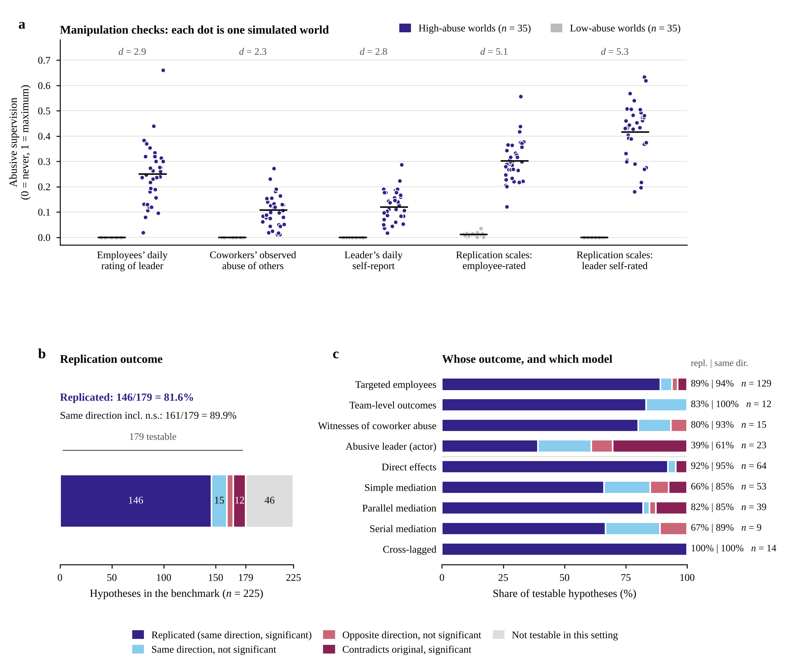
Figure 2. Manipulation checks and replication outcomes. a, Manipulation checks. Each dot is one simulated world (35 high-abuse, 35 low-abuse), and horizontal bars are condition means. Scores are rescaled to 0–1. All five indicators separate the two conditions completely, whether abuse is reported by the targeted employees, by coworkers who observed it, or by the leader himself. b, Outcomes of the 225 hypotheses in the benchmark. A hypothesis is replicated when its effect has the predicted direction and its 95% cluster-bootstrap confidence interval excludes zero. c, Replication by whose outcome the hypothesis concerns and by model type. Numbers at right give the replication rate, the same-direction rate, and the number of testable hypotheses.

Breadth of Replication
Replication was not confined to the effects of abuse on the targeted employee (Table 5 and Figure 2c). It extended to bystanders who witnessed abuse of coworkers, to team-level outcomes, and to the abusive leader himself, whose replicated hypotheses concern the costs of abuse for the leader, such as guilt, rumination, and a perceived loss of moral credits. Replicated hypotheses spanned direct effects, all three forms of mediation, and lagged effects from cross-lagged designs, all 14 of which replicated. They also came from every original design. Hypotheses from multiwave field surveys replicated in 92% of cases, those from cross-sectional surveys in 76%, and 12 of the 14 hypotheses from experiments replicated, including all 10 from scenario experiments and both from the field experiment. The two failures came from a laboratory experiment and predicted a short-term benefit of abuse for the abuser. Diary hypotheses replicated least often (41%).
Table 5. Replication by perspective, model, outcome, and original design
Group | Hypotheses | Replicated | Predicted direction
Perspective
Targeted employees | 129 | 115 (89%) | 121 (94%)
Bystanders | 15 | 12 (80%) | 14 (93%)
Team-level outcomes | 12 | 10 (83%) | 12 (100%)
Abusive leader | 23 | 9 (39%) | 14 (61%)
Model
Direct effect | 64 | 59 (92%) | 61 (95%)
Simple mediation | 53 | 35 (66%) | 45 (85%)
Parallel mediation | 39 | 32 (82%) | 33 (85%)
Serial mediation | 9 | 6 (67%) | 8 (89%)
Cross-lagged design (lagged effect) | 14 | 14 (100%) | 14 (100%)
Outcome
Emotion and well-being | 36 | 32 (89%) | 33 (92%)
Attitude and cognition | 48 | 44 (92%) | 46 (96%)
Behavior | 95 | 70 (74%) | 82 (86%)
Original design
Multiwave field survey | 102 | 94 (92%) | 97 (95%)
Cross-sectional field survey | 41 | 31 (76%) | 38 (93%)
Experiment | 14 | 12 (86%) | 12 (86%)
Diary or experience sampling | 22 | 9 (41%) | 14 (64%)

Boundaries of the Method
Replication failures were not scattered at random. Three a priori features predicted them in the main model, and a fourth did so once the diary hypotheses took their within-person results (Table 6 and Figure 3).
Table 6. Predictors of replication (179 hypotheses from 46 articles)
Factor (reference) | Hypotheses | Firth OR [95% CI] |  | p | Ordinal OR (p) | Within-person sensitivity OR (p)
Predicts a benefit, an adaptive response, or no effect (predicts harm) | 18 | 0.02 [0.00, 0.34] |  | .003 | 0.01 (< .001) | 0.03 (.062)
Within-person, short window (between persons) | 26 | 0.19 [0.01, 7.66] |  | .33 | 0.55 (.46) | 0.05 (.032)
Bystander (targeted employee) | 15 | 0.62 [0.00, 3.28] |  | .41 | 0.81 (.86) | 0.59 (.30)
Abusive leader (targeted employee) | 23 | 0.05 [0.00, 1.48] |  | .056 | 0.21 (.19) | 0.06 (.047)
Team (targeted employee) | 12 | 0.11 [0.01, 1.61] |  | .11 | 0.30 (.73) | 0.16 (.26)
Hostile or deviant outcome | 21 | 0.02 [0.00, 0.07] |  | .001 | 0.05 (.012) | 0.03 (.001)
Mediation model (direct and cross-lagged effects) | 101 | 0.02 [0.00, 0.10] |  | .002 | 0.08 (< .001) | 0.05 (.004)
Added one at a time to the main model, outcomes rated by others replicated less readily than self-rated outcomes (OR = 0.09, p = .019), and hypotheses that abuse lowers something good replicated less readily than hypotheses that abuse raises something bad (OR = 0.07, p = .020). The categories of theoretical mechanism (all p > .12), the original authors’ verdict (p = .67), and original sample size (p = .17) did not predict replication. Only 33 hypotheses did not replicate, so the odds ratios are extreme and should be read for their direction and significance.
Boundary 1: hypotheses predicting that abuse brings a benefit, compensation, or an adaptive response almost never replicated. This was the strongest and most stable predictor. Hypotheses predicting that abuse harms someone replicated in 145 of 161 cases (90%). Hypotheses predicting a benefit (such as short-term recovery or a sense of power for the abuser), compensation (the abuser showing more consideration out of guilt), or an adaptive response (the target seeking feedback or turning to low-effort recovery), together with hypotheses predicting that a path does not operate, replicated in 1 of 18 cases. All 9 significantly reversed hypotheses belong to this type. One possible explanation is that alignment-trained language models carry a uniform schema that abuse is harmful. Because the 18 hypotheses come from 6 articles, we treat this as a proposition for the main study to test rather than a settled conclusion.
Boundary 2: the closer an outcome is to observable behavior directed at others, the harder it was to replicate. Among hypotheses predicting harm, emotional and attitudinal outcomes replicated in 75 of 76 cases (99%), behaviors in 70 of 85 (82%), self-rated outcomes in 123 of 131 (94%), and outcomes rated by others in 22 of 30 (73%). Hostile and deviant behavior is the clearest case. It replicated as a direct or cross-lagged effect in 11 of 12 cases but through a mediator in only 2 of 9. The leader enacted the conduct his persona described, and employees reported its emotional consequences, yet they rarely turned hostile in return, and hostile behaviors stayed close to zero on the 0–1 scale even in the high-abuse condition. Moral alignment within language models may suppress spontaneous antisocial behavior and so bias tests of hypotheses about it.
Boundary 3: mediation chains replicated less often than direct effects. Mediation models replicated in 73 of 101 cases (72%) and showed the predicted direction in 86 (85%), against 73 of 78 (94%) for direct and cross-lagged effects. The difference remained after controlling for the other factors (OR = 0.02). Failures usually occurred on the path from mediator to outcome, which overlaps with the floor effect in Boundary 2.
Boundary 4: within-person, short-window hypotheses reflect a mismatch of time window. Hypotheses whose original studies tested within-person relations from one day to the next, or states measured right after a manipulation, replicated in 11 of 26 cases (42%) in the main analysis, against 135 of 153 (88%) for between-person hypotheses. The within-person, day-level tests supported 6 of the 24 diary hypotheses, and the multilevel models of the model-faithful re-estimation supported 5. A leader’s daily abuse lowered the team’s daily work engagement and his own relaxation in the evening and raised his perceived loss of moral credits, and an employee’s daily experience of abuse raised that day’s need for recovery. Several compensation hypotheses that were significantly reversed between persons were no longer reversed within persons, so part of the failure in Boundary 1 may reflect the time window of the test. Power is the main limit of these tests. The leader’s daily abuse is always zero in the low-abuse condition, so the tests rely on the 35 high-abuse worlds with about five days each.
Two further observations bear on how the method should be used. First, the theoretical mechanism did not predict replication. Among between-person hypotheses predicting harm, justice and social exchange hypotheses replicated in 53 of 53 cases, resource hypotheses in 14 of 15, displaced aggression in 12 of 13, discrete emotions in 27 of 32, self and identity in 16 of 19, team process and motivation in 10 of 12, and morality in 3 of 5. Second, the strength of the original evidence did not predict replication. Of the 21 testable hypotheses that the original articles reported as not supported, 17 (81%) were significant in the predicted direction in the simulation. The simulation thus behaves more like a faithful execution of the theory than a reproduction of a particular sample, and its results should be used with caution when judging a null result of an original study.
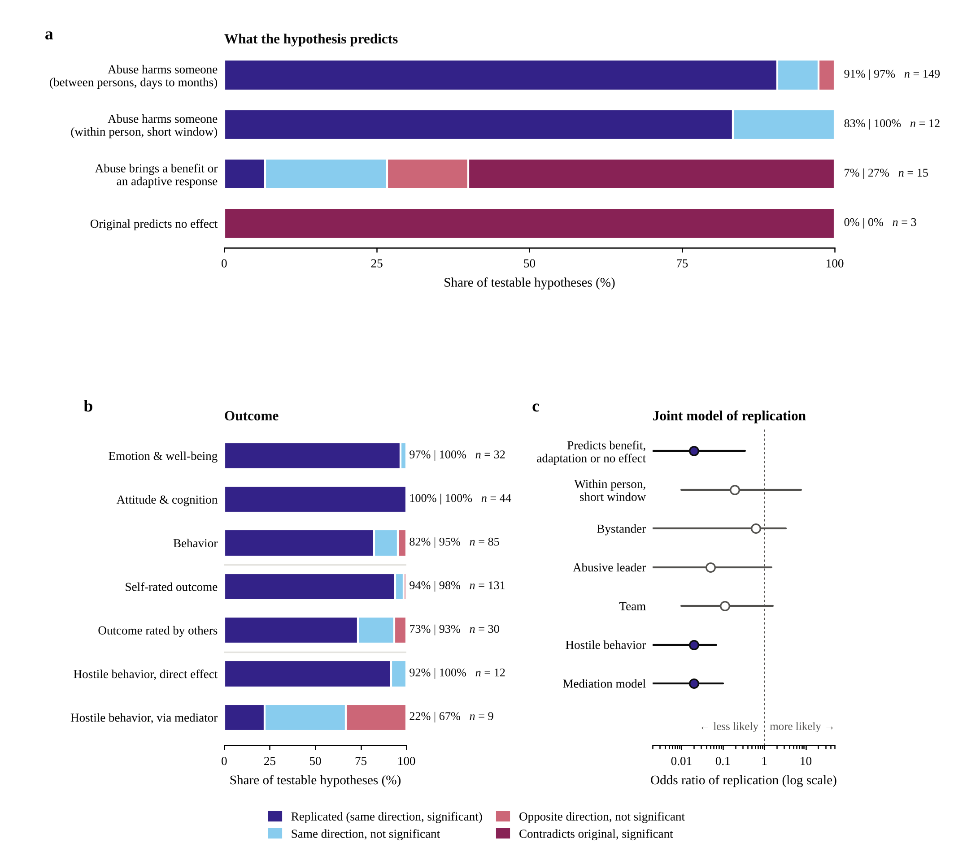
Figure 3. Replication can be predicted from features of the hypothesis. a, By what the hypothesis predicts. Hypotheses predicting that abuse harms someone replicated in most cases, whereas hypotheses predicting a benefit or an adaptive response, or no effect, almost never did. b, By outcome, among hypotheses predicting harm. Emotions and attitudes replicated more often than behaviors, and self-rated more often than other-rated outcomes. Hostile behaviors replicated as direct effects but rarely through a mediator. c, Joint model of replication (Firth logistic regression, 179 hypotheses, with 95% confidence intervals from a bootstrap that resamples original articles). Filled points mark intervals that exclude 1.

Model-Faithful Re-Estimation
Table 7 compares the main analysis with the model-faithful re-estimation. Of the 81 re-estimated hypotheses, 79 could be estimated, and the verdict was the same for 57 of them. The 98 hypotheses that were not re-estimated are unchanged.
Table 7. Model-faithful re-estimation compared with the main analysis
Model | Re-estimated | Estimable | Replicated, main analysis | Replicated, model-faithful | Same verdict
Parallel mediators estimated jointly | 33 | 33 | 30 | 20 | 19
Cross-lagged, controlling for the earlier wave of the outcome | 14 | 12 | 12 | 11 | 11
Diary and experience sampling, multilevel model | 24 | 24 | 11 | 5 | 18
Team level, world means | 9 | 9 | 7 | 6 | 8
Cross-level 2-1-1 mediation | 1 | 1 | 1 | 1 | 1
Total | 81 | 79 | 61 | 43 | 57
Note. Counts of replicated hypotheses and of same verdicts refer to the estimable hypotheses.
The decline from 81.6% to 71.5% comes mainly from two sources. The first is parallel mediation. The mediators of each parallel set were highly correlated in the simulated data (absolute correlations of .78 to .92), so a joint model divides one shared indirect path among nearly redundant mediators. The total indirect effect remained significant in all 13 parallel sets, so abuse still operated through these mediators, but the simulation did not reproduce the distinctness of closely related constructs such as procedural and interactional justice. The second is the diary designs. The simulation reproduced the between-person differences that abuse creates more readily than its day-to-day consequences, in particular for the leader, whose guilt differed between abusive and non-abusive leaders but did not rise on days with more abuse. Both point to further boundaries of the method rather than to a failure to produce the effects of abuse as such.

Cost
The 70 simulated worlds cost about USD 70, or about USD 0.39 per testable hypothesis. For the same 52 articles, the 73 studies with sample information involved about 23,900 participants, 49,000 questionnaires, and 7,240 participant-hours in their final samples. Collected through crowdsourcing, these data would cost at least USD 52,000 at the MTurk rate and USD 116,000 at the Prolific rate, or about USD 291 per testable hypothesis. The simulation therefore costs about 1/740 to 1/1,650 of the human studies. The estimate is a lower bound for the human side, since it excludes attrition, access to organizations, the time leaders spend rating several subordinates, ethics review, and translation. The cost advantage is meaningful only together with the replication rate.

Limitations
These are pilot results with 35 worlds per condition, and the main study will have about 50. Personality sets are reused and the conditions are not matched one to one, although the two sensitivity analyses leave the conclusions unchanged. Intervals of weeks to months in the original studies are compressed into five workdays, which limits within-person tests. The experimental procedures of the original studies are approximated by the world-level manipulation. For example, where an original study abused a single employee, the simulated leader treats the whole team in the same style. All runs so far used one model, deepseek-flash, so Boundaries 1 and 2 may partly reflect this model’s alignment, and the main study will rerun the design on other models. The output example in the answering prompt shows the midpoint of each scale, which may pull answers toward the midpoint, and it will be replaced before the main runs. The reverse-keyed items still need a human check, and the analysis of predictors of replication is exploratory, with coding done after the results were known. The main analysis uses simplified estimators, and even the model-faithful re-estimation omits the original control variables, so a replication shows that the predicted relation appears in the simulated data, not that the original model is reproduced in full. Finally, replication does not mean that the simulation can replace human studies, because it produces theory-predicted effects even where human data do not support them.

References
Ferris, D. L., Yan, M., Lim, V. K. G., Chen, Y., & Fatimah, S. (2016). An approach–avoidance framework of workplace aggression. Academy of Management Journal, 59(5), 1777–1800. https://doi.org/10.5465/amj.2014.0221
Goldberg, L. R., Johnson, J. A., Eber, H. W., Hogan, R., Ashton, M. C., Cloninger, C. R., & Gough, H. G. (2006). The International Personality Item Pool and the future of public-domain personality measures. Journal of Research in Personality, 40(1), 84–96. https://doi.org/10.1016/j.jrp.2005.08.007
Liao, Z., Yam, K. C., Johnson, R. E., Liu, W., & Song, Z. (2018). Cleansing my abuse: A reparative response model of perpetrating abusive supervisor behavior. Journal of Applied Psychology, 103(9), 1039–1056. https://doi.org/10.1037/apl0000319
Mackey, J. D., McAllister, C. P., Brees, J. R., Huang, L., & Carson, J. E. (2018). Perceived organizational obstruction: A mediator that addresses source–target misalignment between abusive supervision and OCBs. Journal of Organizational Behavior, 39(10), 1283–1295. https://doi.org/10.1002/job.2293
McAllister, C. P., Mackey, J. D., & Perrewé, P. L. (2018). The role of self-regulation in the relationship between abusive supervision and job tension. Journal of Organizational Behavior, 39(4), 416–428. https://doi.org/10.1002/job.2240
Mitchell, M. S., & Ambrose, M. L. (2007). Abusive supervision and workplace deviance and the moderating effects of negative reciprocity beliefs. Journal of Applied Psychology, 92(4), 1159–1168. https://doi.org/10.1037/0021-9010.92.4.1159
Open-Source Psychometrics Project. (n.d.). Big Five Personality Test [Data set]. http://openpsychometrics.org/_rawdata/
Page, M. J., McKenzie, J. E., Bossuyt, P. M., Boutron, I., Hoffmann, T. C., Mulrow, C. D., et al. (2021). The PRISMA 2020 statement: An updated guideline for reporting systematic reviews. BMJ, 372, n71. https://doi.org/10.1136/bmj.n71
Park, J. S., O’Brien, J. C., Cai, C. J., Morris, M. R., Liang, P., & Bernstein, M. S. (2023). Generative agents: Interactive simulacra of human behavior. In Proceedings of the 36th Annual ACM Symposium on User Interface Software and Technology (Article 2). ACM. https://doi.org/10.1145/3586183.3606763
Priesemuth, M., & Bigelow, B. (2020). It hurts me too! (or not?): Exploring the negative implications for abusive bosses. Journal of Applied Psychology, 105(4), 410–421. https://doi.org/10.1037/apl0000447
Qin, X., Huang, M., & Ding, J. (2024). AITurk: Using ChatGPT for social science research [Working paper]. SSRN. https://ssrn.com/abstract=4922861
Robins, L. N. (1986). The development and characteristics of the NIMH Diagnostic Interview Schedule. In M. M. Weissman, J. K. Myers, & C. E. Ross (Eds.), Community surveys of psychiatric disorders (pp. 403–427). Rutgers University Press.
Spielberger, C. D., Reheiser, E. C., & Sydeman, S. J. (1995). Measuring the experience, expression, and control of anger. In H. Kassinove (Ed.), Anger disorders: Definition, diagnosis, and treatment (pp. 49–65). Taylor & Francis.
Spitzer, R. L., Kroenke, K., Williams, J. B. W., & Löwe, B. (2006). A brief measure for assessing generalized anxiety disorder: The GAD-7. Archives of Internal Medicine, 166(10), 1092–1097. https://doi.org/10.1001/archinte.166.10.1092
Taylor, S. G., Griffith, M. D., Vadera, A. K., Folger, R., & Letwin, C. R. (2019). Breaking the cycle of abusive supervision: How disidentification and moral identity help the trickle-down change course. Journal of Applied Psychology, 104(1), 164–182. https://doi.org/10.1037/apl0000360
Tepper, B. J. (2000). Consequences of abusive supervision. Academy of Management Journal, 43(2), 178–190. https://doi.org/10.5465/1556375
Tepper, B. J., Moss, S. E., Lockhart, D. E., & Carr, J. C. (2007). Abusive supervision, upward maintenance communication, and subordinates’ psychological distress. Academy of Management Journal, 50(5), 1169–1180. https://doi.org/10.5465/amj.2007.20159918
Williams, L. J., & Anderson, S. E. (1991). Job satisfaction and organizational commitment as predictors of organizational citizenship and in-role behaviors. Journal of Management, 17(3), 601–617. https://doi.org/10.1177/014920639101700305
Xu, E., Huang, X., Jia, R., Xu, J., Liu, W., Graham, L., & Snape, E. (2020). The “evil pleasure”: Abusive supervision and third-party observers’ malicious reactions toward victims. Organization Science, 31(5), 1115–1137. https://doi.org/10.1287/orsc.2019.1349
Zhang, Y., & Liao, Z. (2015). Consequences of abusive supervision: A meta-analytic review. Asia Pacific Journal of Management, 32(4), 959–987. https://doi.org/10.1007/s10490-015-9425-0

Recent evaluations show that language models now match or exceed human coders. They outperformed expert coders in annotating political messages (Törnberg, 2025) and outsourced coders in complex coding of long texts (Bermejo et al., 2025), extraction by a model and verified by a person was at least as accurate as extraction by people alone (Gartlehner et al., 2025), and frontier models extracted 82% to 95% of systematic-review data fields correctly (Vivekanantha et al., 2026). The entries coded here are also highly structured and are stated explicitly in the articles, such as the variables in each role, their raters, the predicted direction, and the authors’ verdict, so they leave little room for interpretation. Structured fields of this kind are where language models perform best, and study characteristics, for example, were extracted correctly in every case (Vivekanantha et al., 2026). The agreement between the two independent coders of hypothesis features is consistent with this (Cohen’s κ of 0.90 to 1.00), and the least structured dimension, the target of the outcome, had the lowest agreement (κ = 0.69). Less structured entries, such as estimates read from path diagrams, are checked by hand.

